January 2023
123 Main St. PO Box 190,
Pelly, SK S0A 2Z0
PH: (306) 595-2124
www.pelly.ca
Email: town.pelly@sasktel.net
Regular Office Hours
Tuesday & Wednesday
9 am to 12 & 1 to 5 pm
Thursday 9 am to 12 & 1-6 pm
Closed to public Monday’s & Friday’s
EXCEPT for Statutory Holidays.

Council Meetings
Council Meetings are regularly scheduled to be 6:00PM on the SECOND Wednesday of each month. Deadline for agenda submissions is the Thursday prior.
Upcoming Meeting Dates:
Feb 8, Mar 8, April 12 2023
at Council Chambers

Transfer Station Hours
Every Wednesday by appointment only. Appointments to be received at office by previous Thursday phoning
(306)595-2124.

Garbage Collection
Household garbage pick-up from the BLACK garbage containers
Bi-weekly on Wednesday’s
Paper Recycle Bins
Located at the
Town Shop yard

Regular Library Hours for 2023
Parkland Regional Library Pelly branch:
Tuesdays from 11 am to 5pm
Thursdays from 1pm to 7pmBy appointment or curbside delivery
Phone: 306-595-2243
Email: pelly@parkland.lib.sk.ca

Payment Types Accepted
E-transfer: town.pelly@sasktel.net
Debit/Credit(3% Fee on Credit Cards only) Cheque, EFT, and Cash

IMPORTANT NOTICES:

OFFICE HOURS
Village Office Regular Business Hours 9:00 – 5:00pm Tuesday , Wednesday 9:00-5:00 and Thursday 9:00 to 6:00
Closed to Public Mondays & Fridays

UTILITY BILLING CHANGES
Effective January 1, 2023 Utilities will be billed as services used and will still remain as being Billed Quarterly (every 3 months).
Utility Bills will be Billed March 30, 2023, and due 30 days on April 29, 2023. Any unpaid Utility Bills after the 30-day grace period will accumulate interest of 17% per annum on any overdue accounts. Utility Bylaw No. 3-2021 will be strictly adhered to. Accounts not paid before April 29, 2023 will have water SHUT OFF on May 1, 2022, no exceptions.

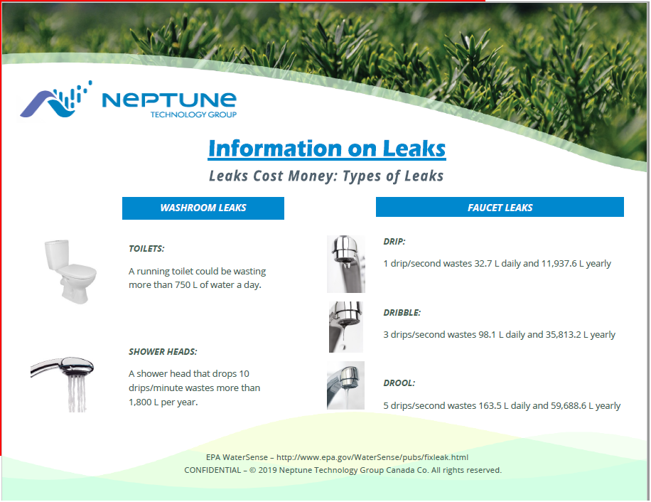

Snow Removal 2023- 2024

Due to complaints from some residents, brought forward to Council regarding the voluntary snow removal not being done in a timely fashion from driveways; The decision of Council for 2023-2024 is that this voluntary service will not continue. It is the responsibility of the rate payer to hire a contractor to remove the snow ridge that the grader has left when clearing the streets.

Please do NOT Feed the Deer
Due to the increased number of deer they are not only eating feed but the bushes and plants in resident’s yards.

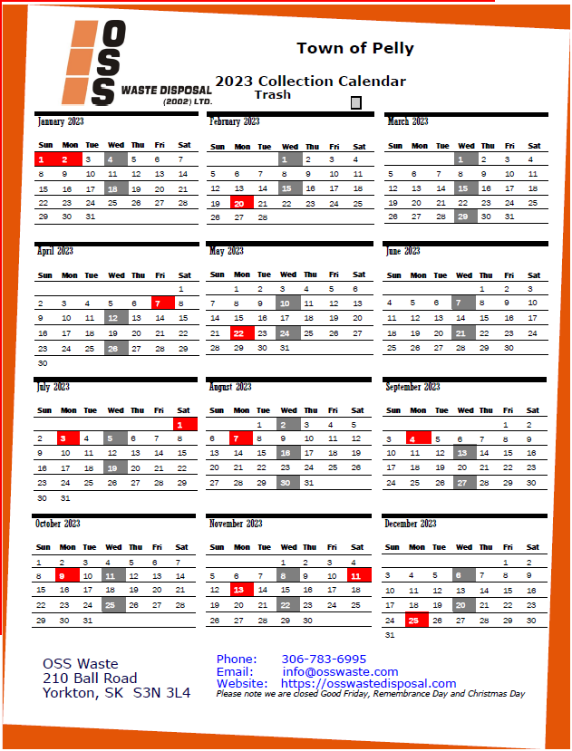  FACEBOOK EMERGENCY NOTIFICATION PAGE  Please join our Facebook Page:  New Village of Pelly  To receive immediate notification of:  Fire Evacuation, Water & Sewage Issues, Garbage Issues, Street, Village & Property Maintenance.  TRANSFER STATION HOURS  Wednesday 10:00 by appointment previous Thursday.  (Appointment made prior week is appreciated for work organization.)  VILLAGE OF PELLY WEBSITE  Please visit the Village website for any information you may require within.  https://www.pelly.ca | COMMUNITY EVENTS  PELLY SKATING RINK  Hours: Wednesday 6:00pm-9:00pm, Thursday 4:30pm-7:00pm, Friday 7:00pm-10:00pm, Saturday 1:00pm-4:30pm and 7:00pm -10:00pm, Sunday 1:00pm-5:00pm  Skating Fees: Daily $3.00, Student Seasonal $50.00, Adult Seasonal $75.00, Family(immediate)Seasonal $125.00  BINGO AT HAPPY HEARTS  Starts at 7:30PM  Every Friday & 1st and 3rd Wednesday of every Month  SOUP & SANDWICH AT HAPPY HEARTS  Menu: Soup, sandwich, dessert and beverage. Every 4th Friday of the Month 11:30 am to 1:00 pm  Take out orders available: Please call (306)595-2122.  COFFEE AT HAPPY HEARTS  Every Monday, Wednesday and Saturday 10:00AM – 11:00AM  Every Tuesday morning: Chair Yoga 10:00 am – 11:00 am  Free activities at Happy Hearts every Tuesday 2:00 pm various:  Cards, Board Games, Puzzles, Floor Curling, Pool, Shuffle Board, etc.  ACTIVE AGING EXERCISES  Every Thursday 10:00AM – 11:00 AM at Pelly Happy Hearts. Everyone Welcome Come join the fun!!  THE FRIENDS OF PELLY  The Friends of Pelly have been to Sarcan! To donate to the bottle drive “Drop & Go” is set up at Sarcan! Enter “Pelly playground.” More info: access www.sarcan.ca and look for “drop & go” section. Sarcan will mail your refund to the organization!!  The Friends of Pelly are a Dynamic Organization helping to revitalize the Pelly Community Park with the addition of an Activity Park for all ages to enjoy! If you are interested in volunteering a few hours now & then, volunteering is welcome for this exciting upbeat project! Please Email: elussier@SASKTEL.NET and your name can be added to our appreciated list of volunteers!

