February 2023
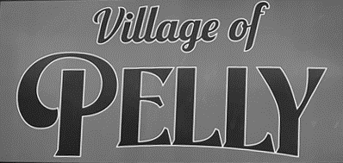
123 Main St. PO Box 190,
Pelly, SK S0A 2Z0
PH: (306) 595-2124
www.pelly.ca
Email: town.pelly@sasktel.net
Regular Office Hours
Tuesday & Wednesday
9 am to 12 & 1 to 5 pm
Thursday 9 am to 12 & 1-6 pm
Closed to public Monday’s & Friday’s
EXCEPT for Statutory Holidays.

Council Meetings
Council Meetings are regularly scheduled to be 6:00PM on the SECOND Wednesday of each month. Deadline for agenda submissions is the Thursday prior.
Upcoming Meeting Dates:
Mar 8, Apr 12, May 10 2023
at Council Chambers

Transfer Station Hours
Every Wednesday by appointment only. Appointments to be received at office by previous Thursday phoning
(306)595-2124.

Garbage Collection
Household garbage pick-up from the BLACK garbage containers
Bi-weekly on Wednesday’s
Paper Recycle Bins
Located at the
Town Shop yard

Regular Library Hours for 2023
Parkland Regional Library Pelly branch:
Tuesdays from 11 am to 5pm
Thursdays from 1pm to 7pmBy appointment or curbside delivery
Phone: 306-595-2243
Email: pelly@parkland.lib.sk.ca

Payment Types Accepted
E-transfer: town.pelly@sasktel.net
Debit/Credit(3% Fee on Credit Cards only) Cheque, EFT, and Cash

IMPORTANT NOTICES:

Water Filtration/Sewage Plant
We have received our $100,000.00 loan, which will be used towards our Water Filters, Sewer Pumps and Infrastructure expenses. The filtration fix is a short term solution, representing a band-aid until the village is hooked up to the regional pipeline. The aged water filtration system is unable to filter the GUDI water in which our wells have been declared. Our priority at this time is to replace the green sands inside the current filters, which will improve the water quality. The sewage plant had both pumps replaced this past fall.
UTILITY BILLING CHANGES
Effective upon approval of the Municipal Board Utilities will be billed as services used and will remain as being
Billed Quarterly (every 3 months). No discounts will be offered towards utility billing.
Monthly or prepayments will be accepted by dividing the quarter bill by 3 (ie. 238/3=79.33)
Utility Billing includes: the water meter reserve levy, water/sewer loan levy, the water/sewer infrastructure loan levy and the water/sewer reserve levy.
The first Utility Bill will be due 30 days after the first quarter billed. Any unpaid Utility Bills after the 30-day grace period will accumulate interest of 2% per month on any overdue accounts. Utility Bylaw No. 16-2023 will be strictly adhered to. Accounts not paid before the 30 days will have
water SHUT OFF, no exceptions.
The water shut off policy will be strictly enforced if not paid.

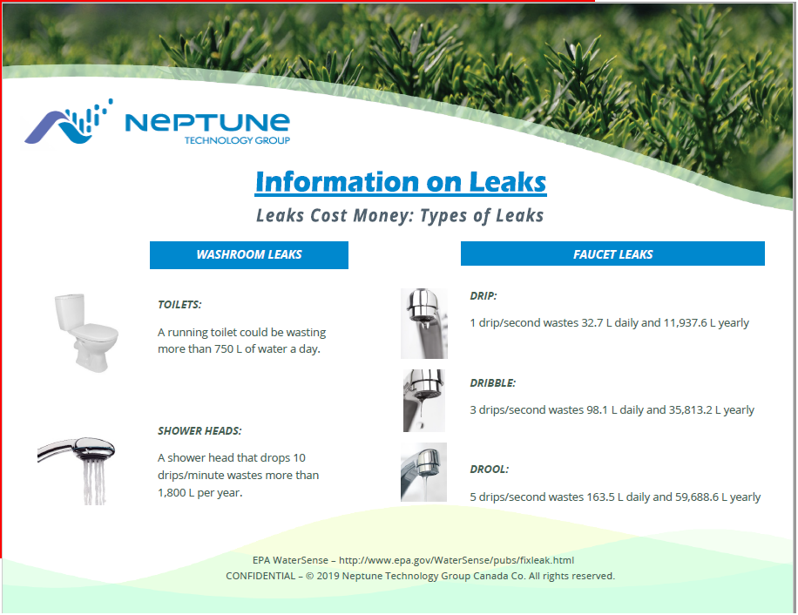

Snow Removal 2023- 2024
It is the decision of Council to continue with the complimentary snow removal service for the Village of Pelly residents. The snow removal will be completed in a feasible and economic route. Priority will be the main access roads, then moving on to the residential and side streets. Council would like to thank the residents that addressed their concerns and appreciation towards this service.

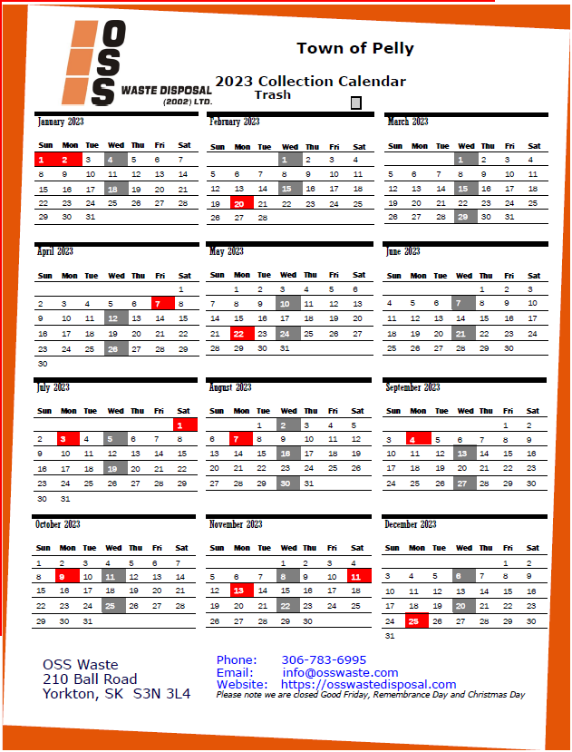  FACEBOOK EMERGENCY NOTIFICATION PAGE  Please join our Facebook Page:  New Village of Pelly  To receive immediate notification of:  Fire Evacuation, Water & Sewage Issues, Garbage Issues, Street, Village & Property Maintenance.  TRANSFER STATION HOURS  Wednesday 10:00 by appointment previous Thursday.  (Appointment made prior week is appreciated for work organization.)  VILLAGE OF PELLY WEBSITE  Please visit the Village website for any information you may require within.  https://www.pelly.ca | COMMUNITY EVENTS  PELLY SKATING RINK  Hours: Wednesday 6:00pm-9:00pm, Thursday 4:30pm-7:00pm, Friday 7:00pm-10:00pm, Saturday 1:00pm-4:30pm and 7:00pm -10:00pm, Sunday 1:00pm-5:00pm  Skating Fees: Daily $3.00, Student Seasonal $50.00, Adult Seasonal $75.00, Family(immediate)Seasonal $125.00  BINGO AT HAPPY HEARTS  Starts at 7:30PM  Every Friday & 1st and 3rd Wednesday of every Month  SOUP & SANDWICH AT HAPPY HEARTS  Menu: Soup, sandwich, dessert and beverage. Every 4th Friday of the Month 11:30 am to 1:00 pm  Take out orders available: Please call (306)595-2122.  COFFEE AT HAPPY HEARTS  Every Monday, Wednesday and Saturday 10:00AM – 11:00AM  Every Tuesday morning: Chair Yoga 10:00 am – 11:00 am  Free activities at Happy Hearts every Tuesday 2:00 pm various:  Cards, Board Games, Puzzles, Floor Curling, Pool, Shuffle Board, etc.  ACTIVE AGING EXERCISES  Every Thursday 10:00AM – 11:00 AM at Pelly Happy Hearts. Everyone Welcome Come join the fun!!  THE FRIENDS OF PELLY  The Friends of Pelly have been to Sarcan! To donate to the bottle drive “Drop & Go” is set up at Sarcan! Enter “Pelly playground.” More info: access www.sarcan.ca and look for “drop & go” section. Sarcan will mail your refund to the organization!!  The Friends of Pelly are a Dynamic Organization helping to revitalize the Pelly Community Park with the addition of an Activity Park for all ages to enjoy! If you are interested in volunteering a few hours now & then, volunteering is welcome for this exciting upbeat project! Please Email: elussier@SASKTEL.NET and your name can be added to our appreciated list of volunteers!

